Push NOTIFICATIONS

<https://developers.google.com/web/updates/2015/03/push-notifications-on-the-open-web>

<https://firebase.google.com/docs/cloud-messaging/>

<https://firebase.google.com/docs/database/web/start>

<https://firebase.google.com/docs/database/web/read-and-write>

<https://firebase.google.com/docs/storage/web/upload-files>

https://firebase.google.com/docs/cloud-messaging/js/receive

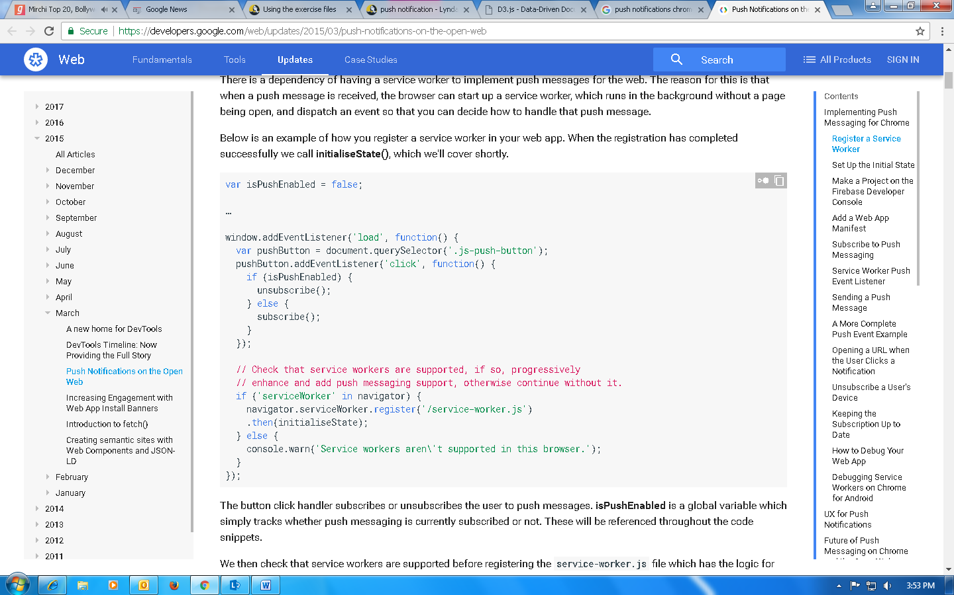

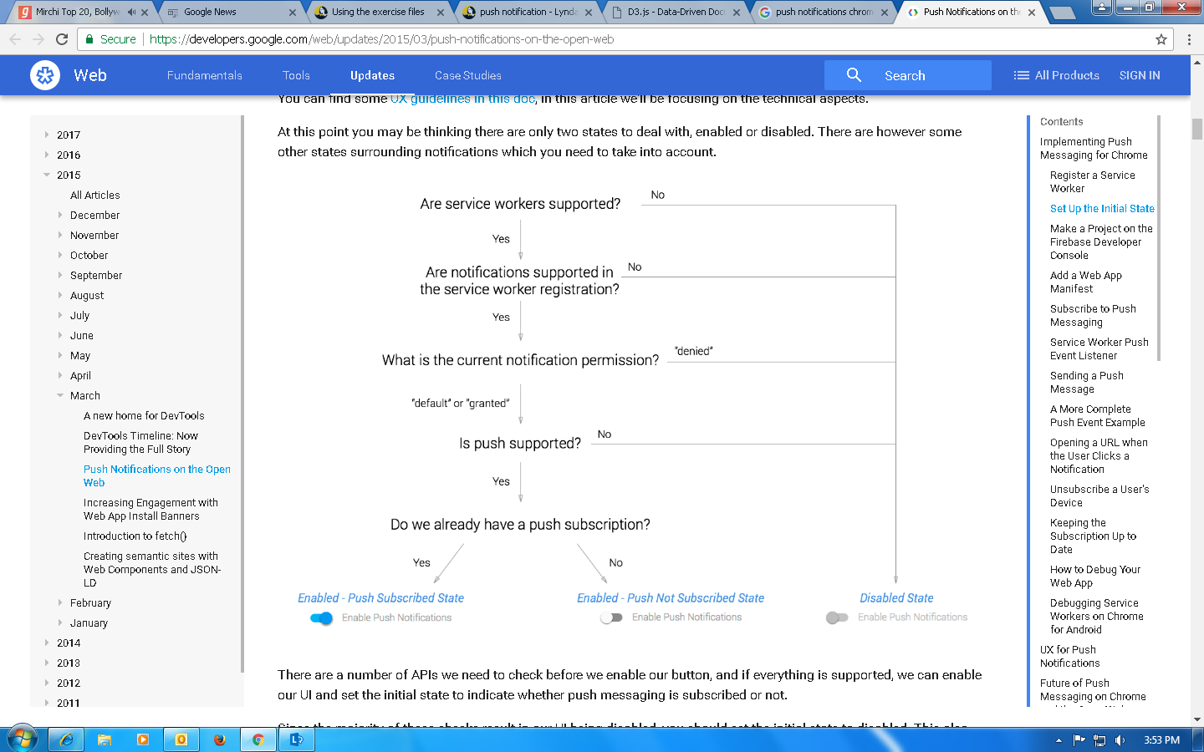

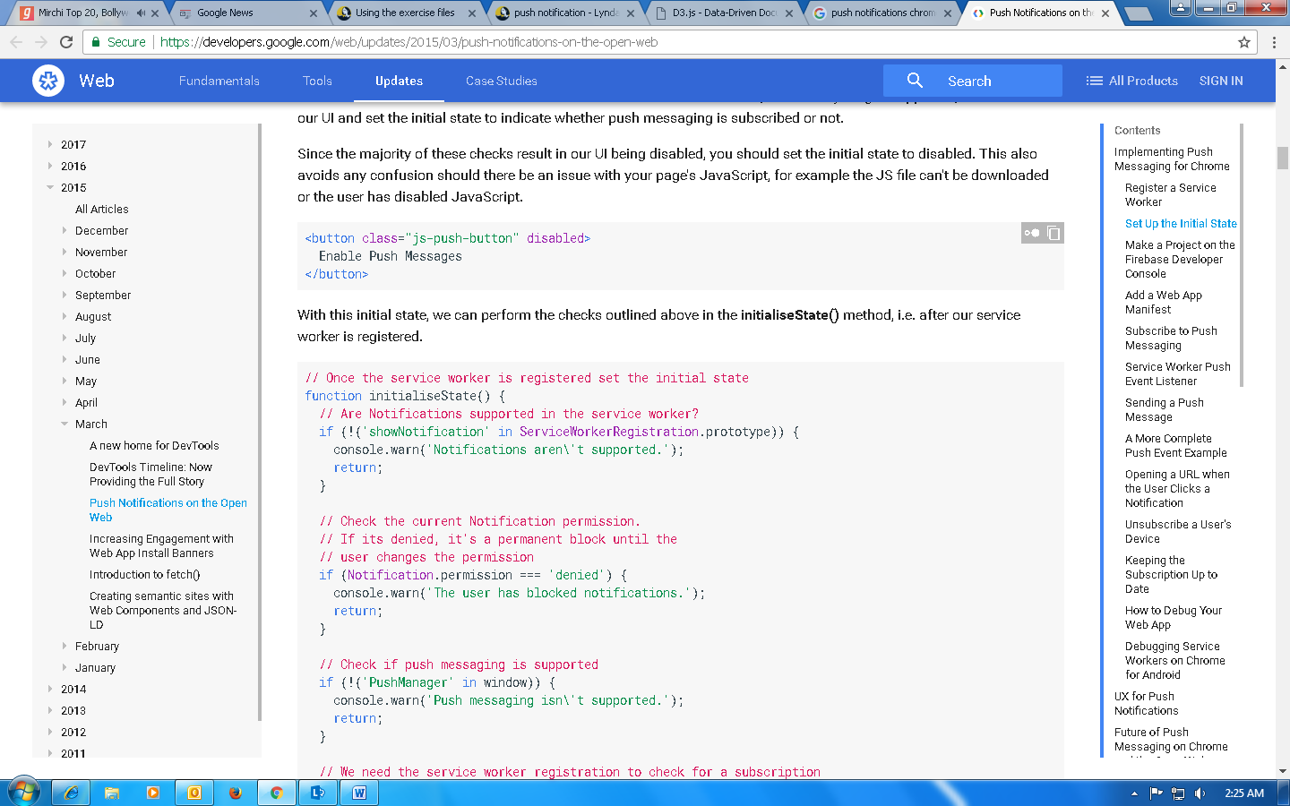

FIREBASE WRITE OPERATION

